Itinerary Details Day by Day
Day 1 Beijing Arrival
Welcome to Beijing, the capital of China, rich in history and culture.
Your lifetime China tour begins with welcome from your local guide at theBeijing airport. Then be escorted to your hotel in a private vehicle. The rest of today is yours to acclimatize or explore the vast metropolis on your own.
Day 2 Beijing ( B, L )
Today's tour begins to visit the Tiananmen Square, the world's largest plaza. Walking through Tiananmen Gate, you'll enter the splendid Forbidden City, China's No.1 palace complex adorned with imperial treasures.
In the afternoon, you'll marvel at the Temple of Heaven where the emperors worshipped heaven and prayed for peace and harvest.
After the tour, back to your hotel.
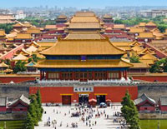
Day 3 Beijing ( B, L )
This morning tour will take you to size up the world-famous Great Wall(Mutianyu section), the key symbol of China. Flexible visiting time allows you to enjoy a lifetime trekking trip (1-2 hours' hiking), or witness the breathtaking views of this man-made wonder by taking a cable car.
After the Wall visit, you'll take a leisurely stroll along the tranquil Sacred Roadto explore the Ding Tomb of Ming Imperial Tombs.
Feel tired after a whole day tour? You're offered with a free foot massage. In the evening, try the flavorful dish of Peking Roast Duck Dinner. (Optional)
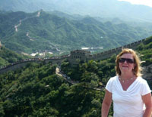
Day 4 Beijing & Flight to Xian ( B, L )
Today after breakfast, you'll visit the fabulous Summer Palace, the largest and best-preserved imperial garden in China, the next 'must see' site after the Great Wall and the Forbidden City.
Then you will be escorted to the airport for a 2-hour flight to Xian, the ancient heart of China. Upon arrival in Xian, your local guide will greet and guide you to your hotel. The rest of the day is free on your own.
Day 5 Xian ( B, L )
Today your first stop is to join the ranks of the incredible Terracotta Warriors, the forbidding sentinels of a death defying emperor, starting out through the silent millennia of history.
In the afternoon, visit the Ancient City Walls, the largest and best-kept city walls on earth. Strolling and cycling on the Walls is quite an enjoyable experience. Today’s tour ends to visit the Bell Tower, a famous landmark of Xian ancient city.
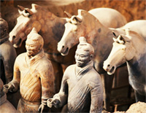
Day 6 Xian & Flight to Guilin ( B, L )
Today after breakfast, you'll visit the Great Mosque, a tranquil and historic mosque that has served Xian's Muslim community for more than a millennium. By the way, you'll stop by the Muslim Community.
Then head to the age-old Big Wild Goose Pagoda, the symbol of the old-line Xian, a well-preserved ancient building and a holy place for Buddhists.
After lunch, be transferred to the airport and take a flight to Guilin (1 hour and 45 minutes), the most scenic Chinese city. Be met and transferred to your hotel by the local guide and the rest of today is free at your leisure.
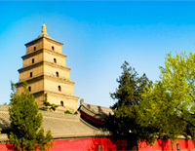
Day 7 Guilin ( B, L )
After breakfast, you'll be driven to Zhujiang Pier to cruise the Li River, a must-do for any Guilin tourists and a mile-long natural gallery.
This was what Bill Clinton said: 'I heard of the name of Li River long ago. Today I visit Li River. It is more vivid and genuine than what I thought before. Nowhere is like Guilin. It makes me think of the traditional Chinese paintings.'
After about 4 hours cruise, disembark at Yangshuo, the paradise of Guilin. Check in your hotel, the rest of today is free to explore Yangshuo and find out why West Street is so popular among tourists.
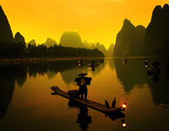
Day 8 Guilin & Flight to Shanghai ( B, L )
Being driven back to Guilin after breakfast (1.5~2 hrs), and have an essential Guilin city tour. The first stop surely is the Elephant Trunk Hill, the city symbol. Then head to visit the fabulous Reed Flute Cave to see the beautiful stalactites, stalagmites, stone pillars, and stone flowers with various shapes.
After the tour, be escorted to the airport for your flight to Shanghai, the most cosmopolitan city of China. Upon your arrival, transferred to your hotel in Shanghai in private vehicle.
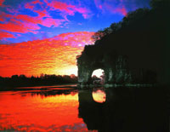
Day 9 Shanghai ( B, L )
After breakfast, you'll visit the Shanghai Urban Planning Exhibition Center, a must-see for all true Shanghainophiles to witness how Shanghai became a cosmopolitan city from a shabby fishing village.
Then walk leisurely around the beautiful Yu Garden, a pleasant enough, well-contained classical Chinese garden, and savor some local flavor snacks at theYu Garden Bazaar.
Later to visit the French Concession to appreciate its old French-style villas and special colonial culture. In the evening, enjoy the breathtaking Acrobatic Show. (Optional)
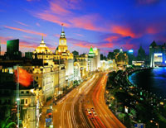
Day 10 Shanghai Departure ( B )
After breakfast, head to the famous Bund to witness Shanghai’s skyline, and stroll along China's No.1 shopping street, Nanjing Road.
Then ascend the Jinmao Tower to get an amazing bird’s eye view of this metropolis. Then continue to Jade Buddha Temple to admire the largest jade Buddha in the world and exquisite religious artifacts.
After the tour, be transferred to the airport for your flight to next destination or back to home.
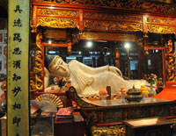
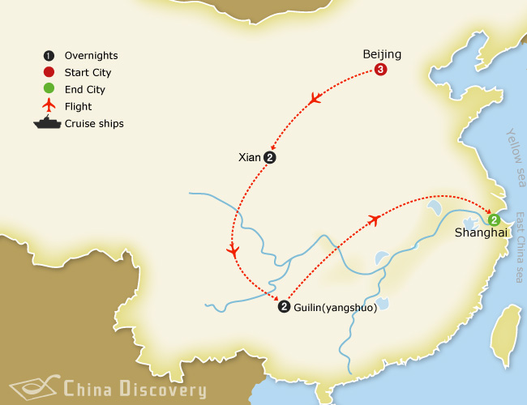

Practical Info about Traveling with Us

Restaurant & Food
The restaurants we will take you for lunch or dinner are all designated tourist restaurants approved by local tourist administration bureau. They have very good sanitary conditions and the food is prepared fresh and clean.
Note: If you have any special dietary needs, just let your travel consultant know while booking.

Vegetarian food Requirement
Vegetarian food in Chinese cuisine culture is usually divided into 3 categories: the Monastery Vegetarian Food, the Court Vegetarian Food and the Folk Vegetarian Food. And the main ingredients are: soybean, taro powder, mushrooms, fresh vegetables and tofu (bean curd). It will be easier to find the vegetarian restaurants in big cities of china, such as: Beijing, Shanghai, Xian, HK, etc.

If allergic to some food
We suggest you to list any food or ingredients that you are allergic to and let our travel consultant know. Then your travel consultant will mark them in the guide’s itinerary, so that our guides in different cities can make some preparations and arrangements in advance.

Do our guide and driver join the meal with us?
Yes, a member of the team will accompany you from UK to China. The tour guides and driver will be at the same restaurants with you, but they will only join the meal when you invite. Sometimes the drivers are shy to join as they usually eat fast and could not understand English talk around the table, so the guide will be with you more often.

Will we be able to try some local foods during our visit?
Yes, you will. There will be some meals excluded in your itinerary as you like, and your private guide will be delighted to give you some suggestions and take you to the local restaurants, if you are interested in local food tasting. But remember, some local snacks may not match your stomach, so ask your guided for more information before eating.

Shopping

What to buy in China?
In China, there are myriads of souvenirs for visitors, and each city has its own specialty.
Some of the best buys are:
- Beijing: Cloisonné; Fresh water pearls
- Xi'an: Replicas of the Terra Cotta soldiers; Tangsancai (Tang Dynasty hand painted China); Antique Furniture
- Shanghai: Silk carpets
- Hangzhou: Longjing Tea; Silk
- Suzhou: Silk
- Guilin: Scroll paintings; China Southern Sea Pearls
- Yunnan: Mounted Butterflies; Pure tea; Dali Batik (tie-dyed fabric)
- Xinjiang: Carpets; jade articles
- Tibet: Thang-ka（tanka）(Sheep skin wall hangings)

How to bargain?
Bargains are not acceptable in big supermarkets and department stores. But in some night markets or tourist shops, you can bargain for a lower price, since the vendors always ask for very high price for a certain item. You’d better ask the opinion of the guide first, and then the guide will tell you the real value and quality of the item. Please note that when the bargain is processing, the guide will be hesitate to help as it may annoy the bosses. Just try to let the guides know you will bargain in advance.

What to do with persistent vendors?
If you do not need something from them, just do not ask for price. Some of the venders are very persisted, and if they keep selling things to you, you can simply say “No, thanks.” (Chinese pronunciation: ”Bu, XieXie”). If they do not give up, you just keep silence. Silence is sometimes useful to handle this situation.

More Tips for free-time shopping
- 1. If you think you have no desire or interest, you do not feel embarrassed to let our guide know DIRECTLY (since some of our guides are enthusiastic in taking you shopping)
- 2. Better to choose the shops run by the state when buying expensive articles.
- 3. Do not shop everything in one city, because every place has its unique local products which worth buying.
- 4. Do not feel obligate to buy anything only because the shop attendants are very kind to you.
- 5. Be smart consumers. Do not spend big money on things you are not familiar with. Do ask for shop guarantee, contacts and certificates when purchasing big items like antiques, jade, arts pieces.
- 6. Leave plenty of time for transactions. When you see something you like - buy it. Usually, you would not find it elsewhere and you would not have time to go back.
- 7. Always verify the date of antiques before you purchase them. Antiques dated before 1795 cannot legally be exported.
- 8. Articles made from rare wild animals are contraband and will be confiscated by customs without compensation.

Emergency calls
Call your guide, or if you can’t find your guide, call your travel consultant or our office immediately. All the phone numbers include in our confirmation letter. Keep the letter with your during your trip.
Note: As our Beijing office is using the different guide arranging system, so we will not be able to provide the Beijing guide information until the day before you arrival, but once we have it, we will email you immediately.

