Introduction to Anyang City, China
- Anyang city is located in the central part of China. It takes 2 hours and 30 minutes to go there from Beijing by express train. Anyang is an ancient city with a history of over 3,000 years and is one of the Eight Ancient Capitals of China. It is one of the well-known birthplaces of Chinese ancient culture.
- Anyang is known as the “Cradle of Chinese Writing” , the place where the oracle bones were found. China’s first library of inscriptions on bones and tortoise shells is located here. About 2 km (1.2 mi) northwest of Anyang are the ruins of the Shang Dynasty capital known as Yin. This massive archaeological site was discovered in 1899, excavated in the decades that followed, and first opened to the public in the 1980s as the Garden Museum of Yinxu. The current museum was opened on 16 March 2005, and the site is inscribed on the UNESCO list of World Heritage Sites.
- There are 5 million people in the whole city and about 2 million people in the downtown area.

The Main School:

Anyang No.1 High School and it’s affiliated school Zhengyi Middle School

Anyang No.1 High School and Zhengyi Middle School ranks 1st and 2nd in the city. They are both the most important high schools in the city.
Anyang No.1 High School:
The campus of Anyang No. 1 high school covers an area of ​​105,000 square meters, including a total building area of 53,000 square meters and green area of 60,000 square meters, with a greening rate of 60%. The school is a quiet and elegant garden-style school. There are now 56 classes, more than 3,300 students, and 226 faculty members, including 182 professional teachers. Among the teaching staff there are five special-grade senior teachers, more than 160 teachers with senior titles, and over 50 teachers are top teachers national-wide or provincial-wide, academic leading teachers and key teachers, four of them are named national outstanding teachers, model teachers and outstanding educators.

School website: http://www.ayyz.cn/

Anyang Zhengyi Middle School
Anyang Zhengyi Middle School is an affiliated private school of Anyang No. 1 High School which was first founded in 2003. In December 2013 the school was renamed as Zhengyi Middle School. The year 2014 witnessed the enrollment of the first 300 junior middle school students in this school.
There are 99 staff teachers in the school , 23 with senior titles and 25 them with intermediate titles. The school occupies a building area of 179,000 square meters with 2500 students.
- The school used to be Anyang Foreign Languages Middle School, which was founded with an investment of 25 million RMB by the municipal government. The school has a garden style environment and advanced facilities. The classroom building, the laboratory building, and the lecture hall together enable the students to enjoy the pleasure of exploring and learning all-round.
- Every classroom is facilitated with multi-media equipment, heating in winter and air-conditioning in summer.
- The audio-video labs, together with the internet network and broadcasting system provide an ideal learning place.
- The students’ dining hall can hold 3000 people at one go. The dorm building is kept clean and neat, which ensures the safe, convenient and comfortable living conditions for the students. The track field and the multi-functional gym are among the best facilitated ones in the city.

Pictures:
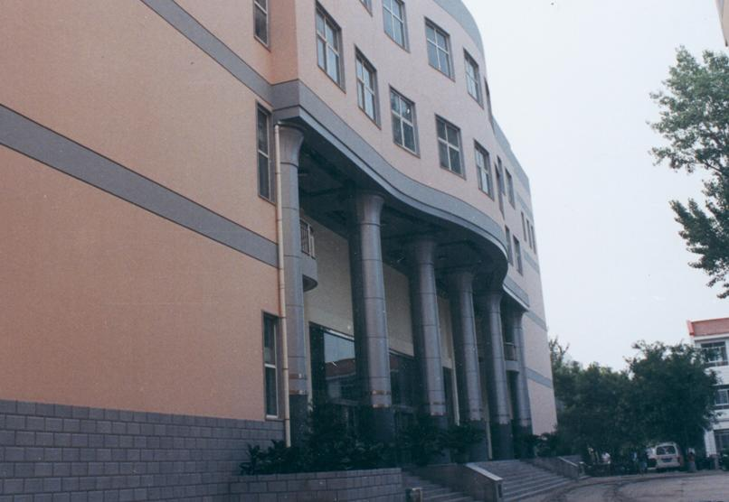

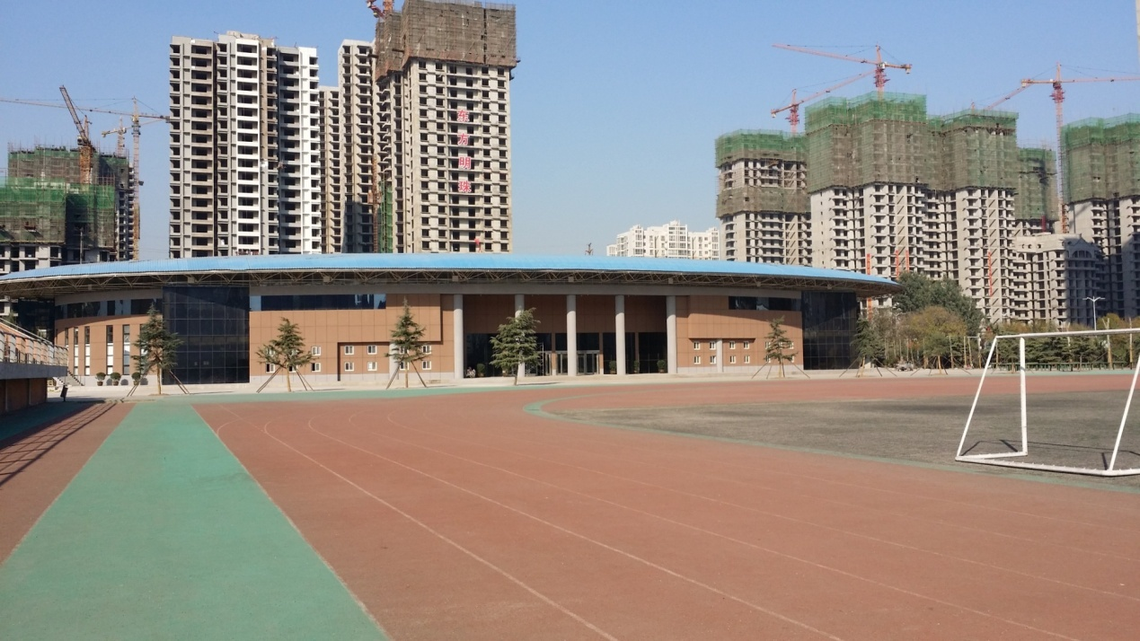
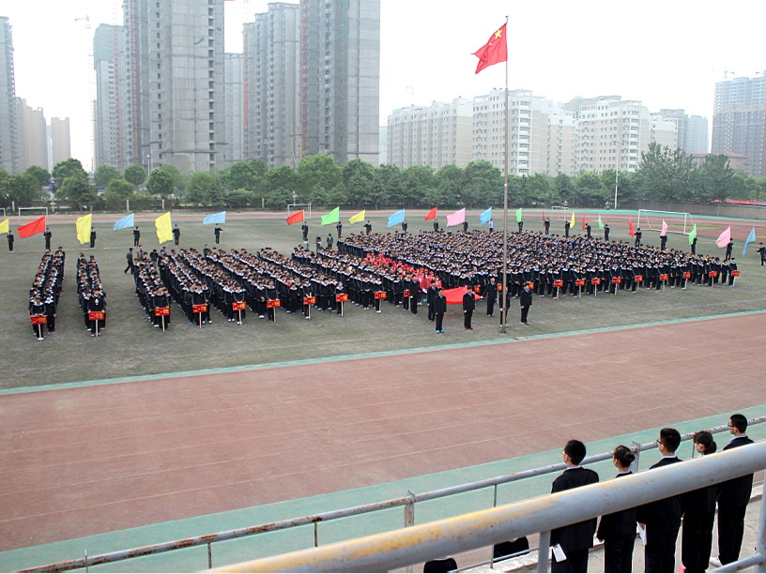

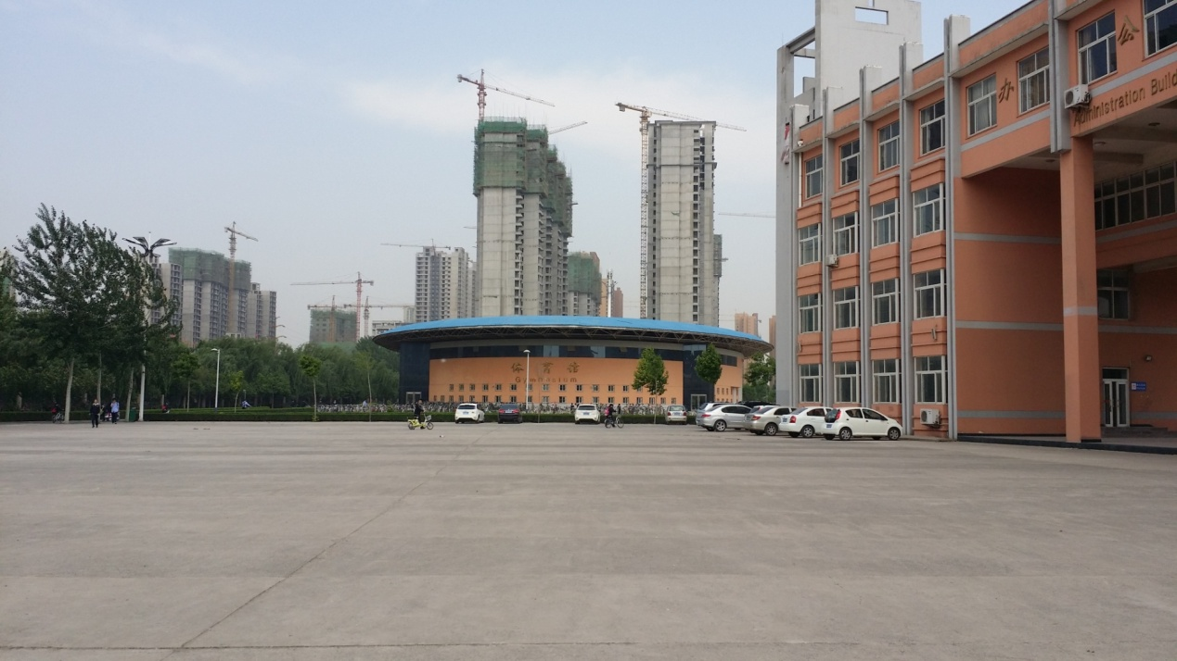

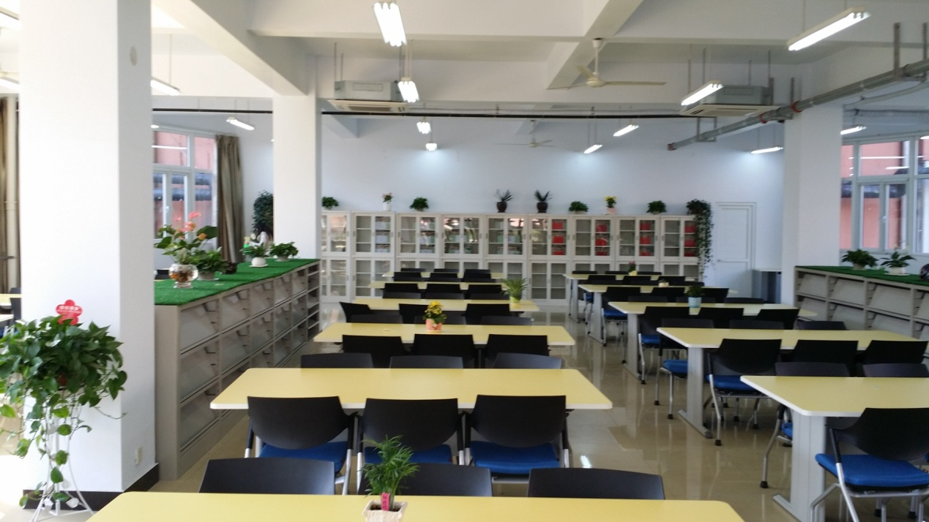

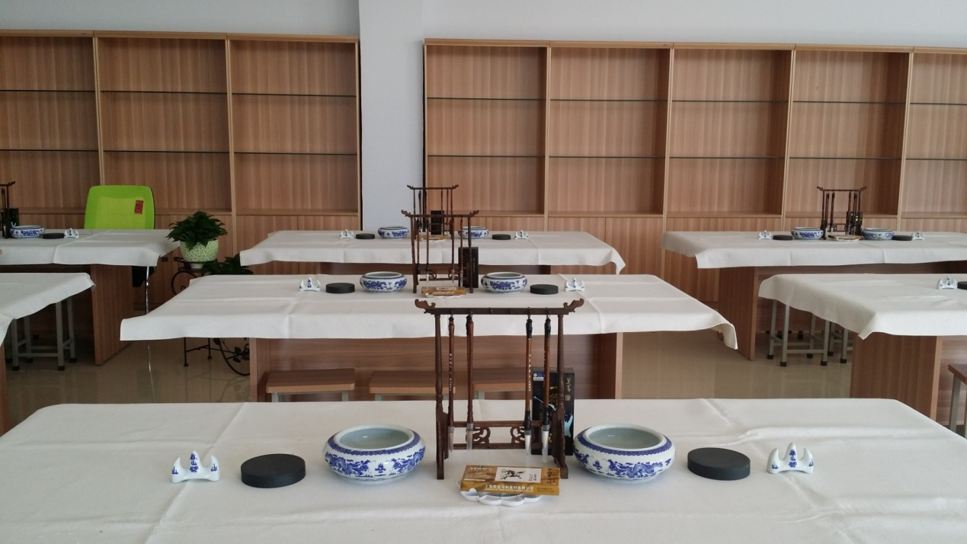

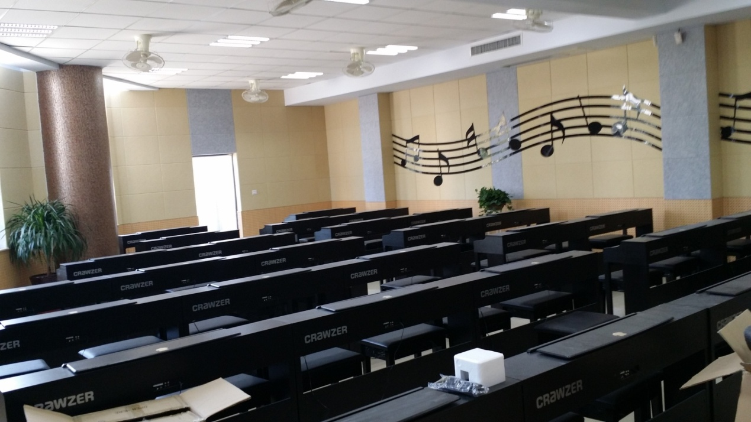

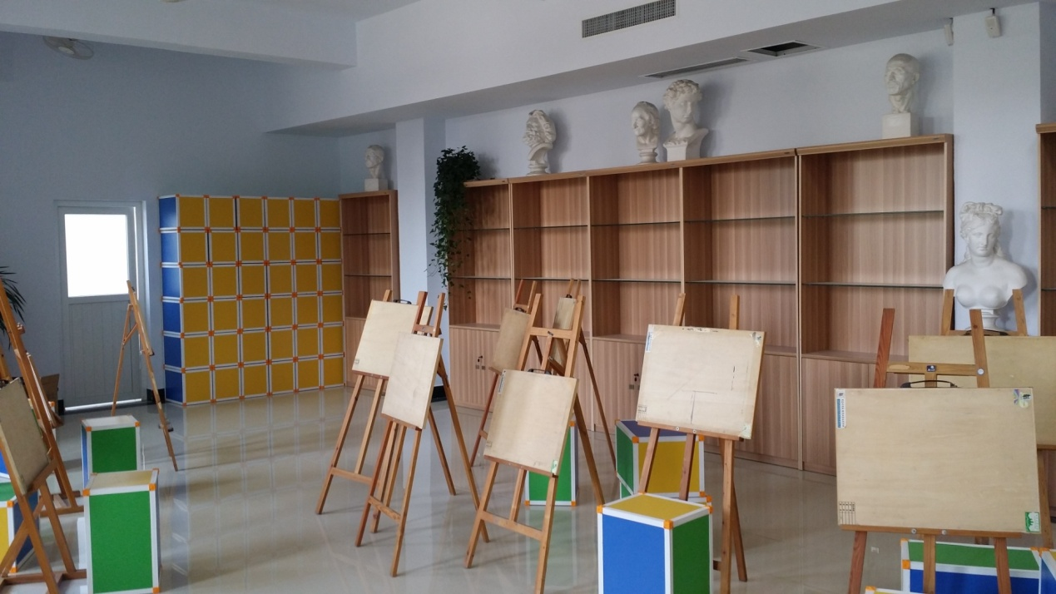

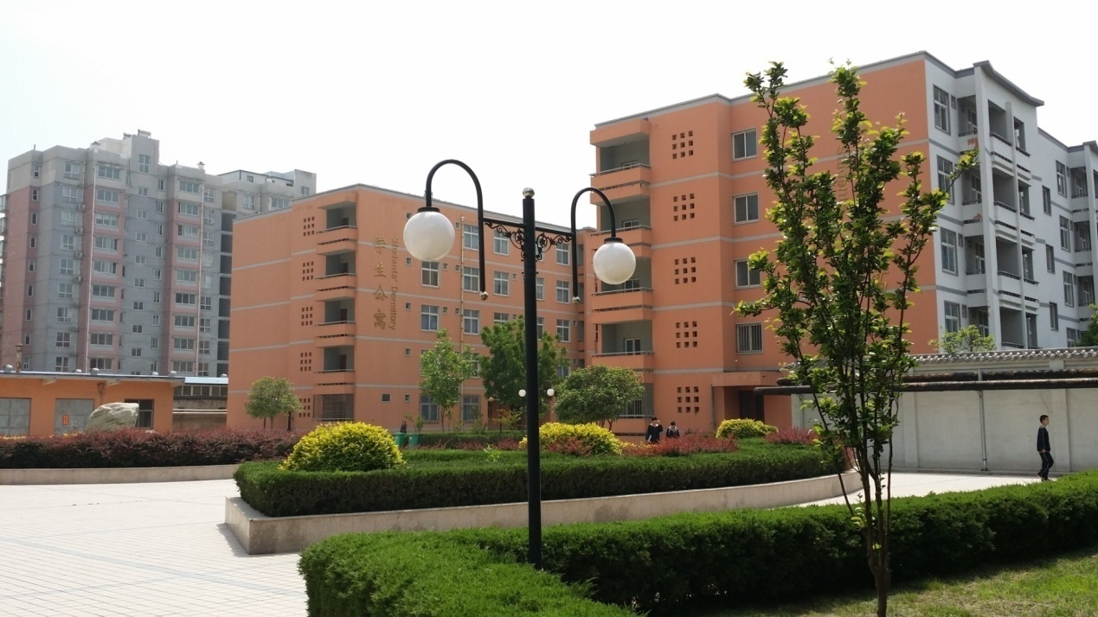
Living Condition:

Teacher’s Apartment Building
